Developmental Testing
In this section of my computer science project, I will be producing evidence of testing at each stage of development.
Testing at each stage
The first test I did was adding a new member, I inputted the following data into the “add member” form

Heading | Realistic Data | Type
Member ID | 2 | String
Name | John | String
Surname | Smith | String
DOB | 19/1/2000 | Date
Address | 22 Random Road | String
Town | Gravesend | String
County | Kent | String
Postcode | DA12 5SA | String
Telephone | 07456325632 | String
Member Status | Yes | String
Expiry Date | 25/12/2018 | Date

I will be using strings for each data set excluding the Date of Birth and Expiry Date, this being because a string enables alphanumeric values as well as extremely large values, which increases freedom of data inputted and reduces restrictions.

Below I will show the data being inputted into my prototype:
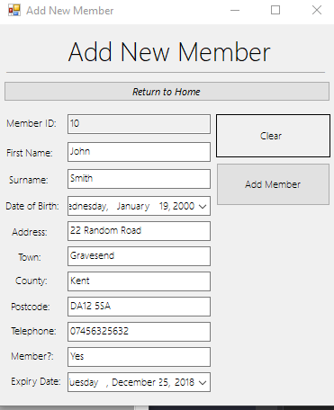

When I click “Add Member”:
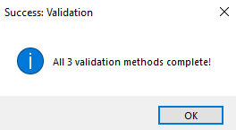

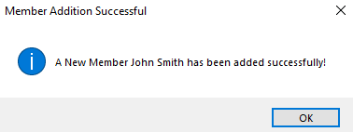

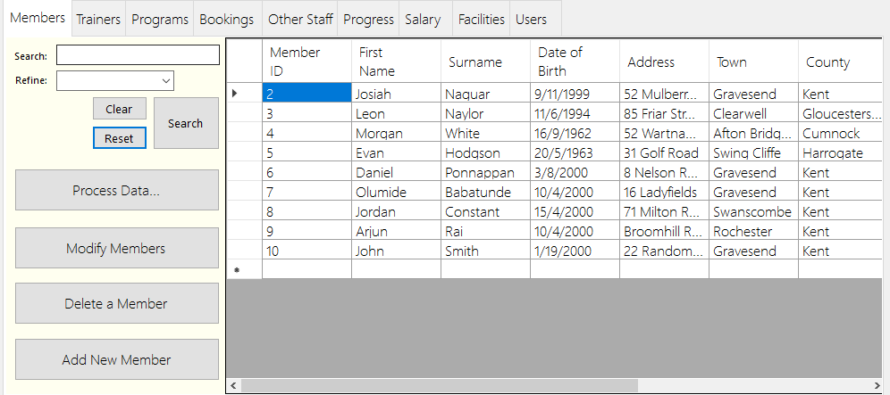
As you can see below, the addition was successful, and now shows on the table within the main form when the “reset” button is selected. Therefore, no changes were required to be made.

I will now do the same for Trainers:
Heading | Realistic Data | Type
Trainer ID | 14 | String
Name | John | String
Surname | Smith | String
DOB | 19/1/2000 | Date
Address | 22 Random Road | String
Town | Gravesend | String
County | Kent | String
Postcode | DA12 5SA | String
Telephone | 07456325632 | String
Salary Band | 2 | String
Status | Full-Time | String

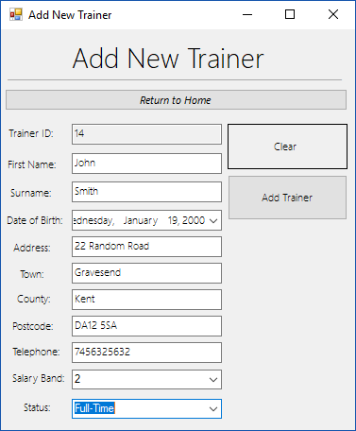

I then click on “Add Trainer”

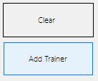

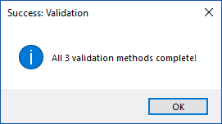

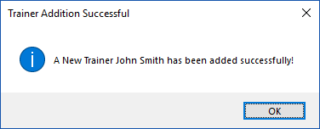

John Smith is now shown with Trainer ID 14.
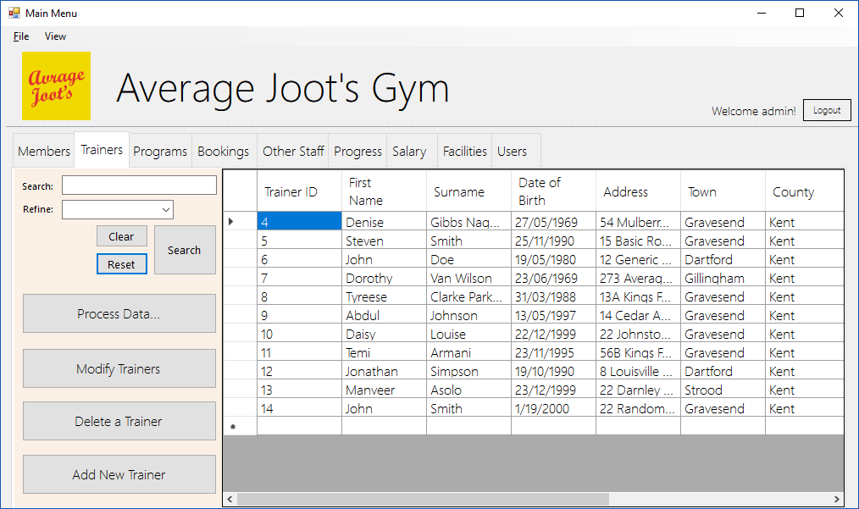

Heading | Realistic Data | Type
Program ID | 6 | String
Name | Freeweight Fanatic | String
Type | Strength | String
Trainer ID | 9 | String
Facility ID | 8 | String

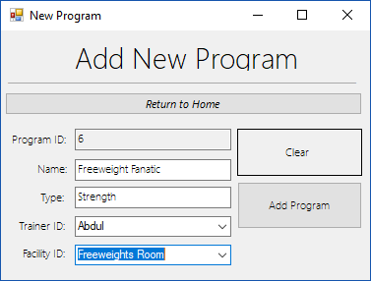
I then click “Add New Program” and input the data, then the same messagebox as previous occurs and the data is added.

I then tested all other addition forms and they all worked successfully and as intended.

The next test I did was logging in with the new login function
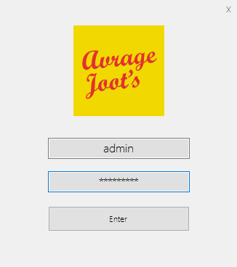
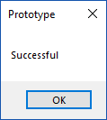

Once I entered the correct username and password, a message box saying “Successful” appeared, after clicking “OK” the main menu appeared.

Here’s evidence of the main menu appearing.
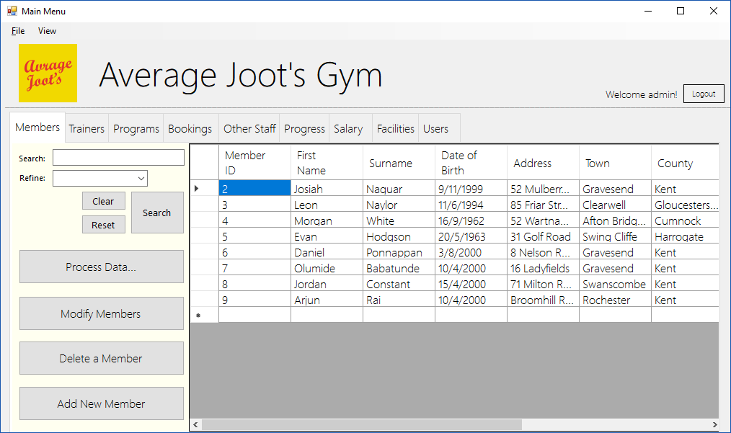

My next test was the delete form, I began with deleting the member “Arjun Rai”
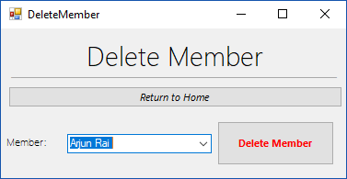
I then clicked “delete member”
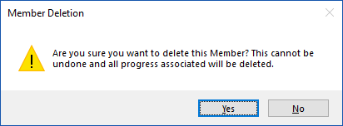

Then I clicked “Yes”
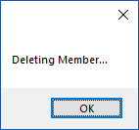
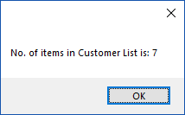
The number of items in the list has been shown to decrease, this suggesting that the test was successful.
However, the “return to home button did not work”, so I added the code to make it work.
Private Sub Button_ReturnHome_Click(sender As Object, e As EventArgs) Handles Button_ReturnHome.Click
MainMenu.Show()
Me.Close()
End Sub

My next test was to attempt to delete Steven Smith.

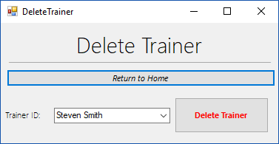

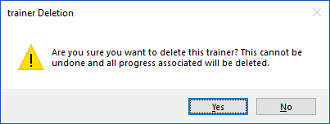
I click “Yes”

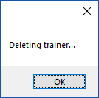
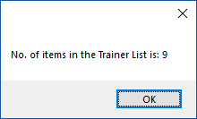
The test was once again, successful. However, the same issue as before had arised (the back to home button wasn’t binded), so I binded the button.
Private Sub Button_ReturnHome_Click(sender As Object, e As EventArgs) Handles Button_ReturnHome.Click
MainMenu.Show()
Me.Close()
End Sub

I then tested the rest of the delete buttons
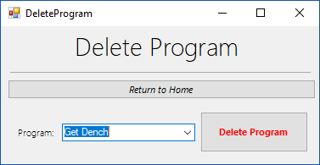

Success

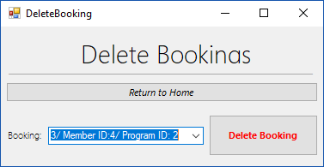
Success

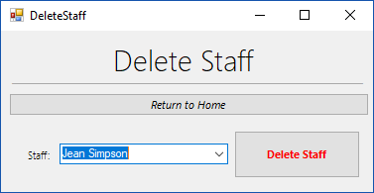
The “Delete Staff” return to home button didn’t work, although the deletion was successful, so I added the code:
Private Sub Button_ReturnHome_Click(sender As Object, e As EventArgs) Handles Button_ReturnHome.Click
MainMenu.Show()
Me.Close()
End Sub

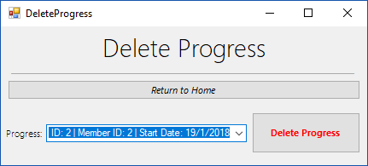

Success

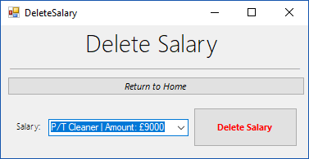

Success

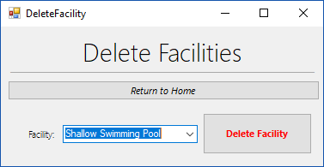

Success

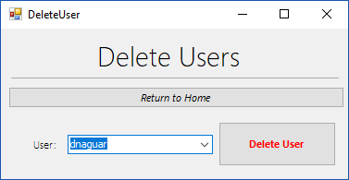

Success

Aside from issues with the binding of the “Return to home” button where stated, all deletions occurred successfully.

The next test I completed was the “Modify Member” section
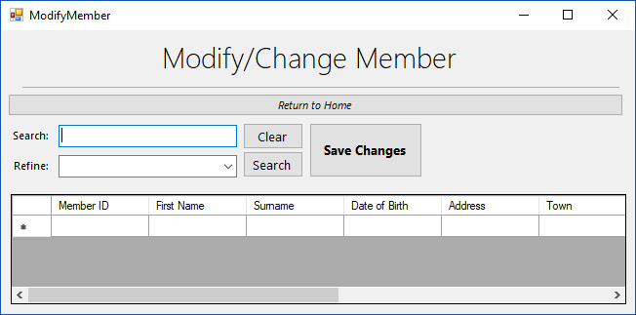
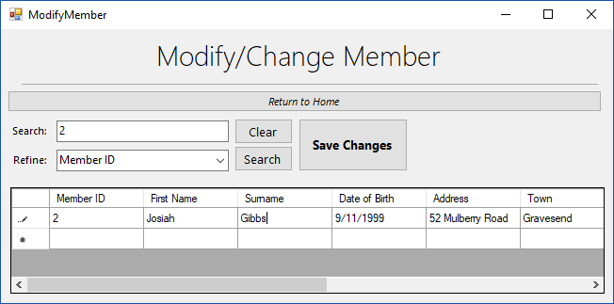

Here, I changed Josiah’s surname from “Naguar” to “Gibbs”, which of works as intended. However, there is no indication unless you go back to the main form and reset the corresponding Table.
